Project Development Phase
Model Performance Test
Date | 28 September 2026
Team ID | 6ab221fbe880316a482c6241
Project Name | Script-Controlled ACL – Restrict Record Access Based on Field Value
Maximum Marks

Model Performance Testing:
Project team shall fill the following information in model performance testing template.
S.No. | Parameter | Values | Screenshot
1. | Model Summary | ServiceNow script-controlled Access Control List (ACL) setup to restrict users from viewing records unless they meet a specific condition. Only users belonging to the EEE branch can view the record.  Note: If the ACL script condition matches (returns true), the record is displayed; otherwise access is denied. | 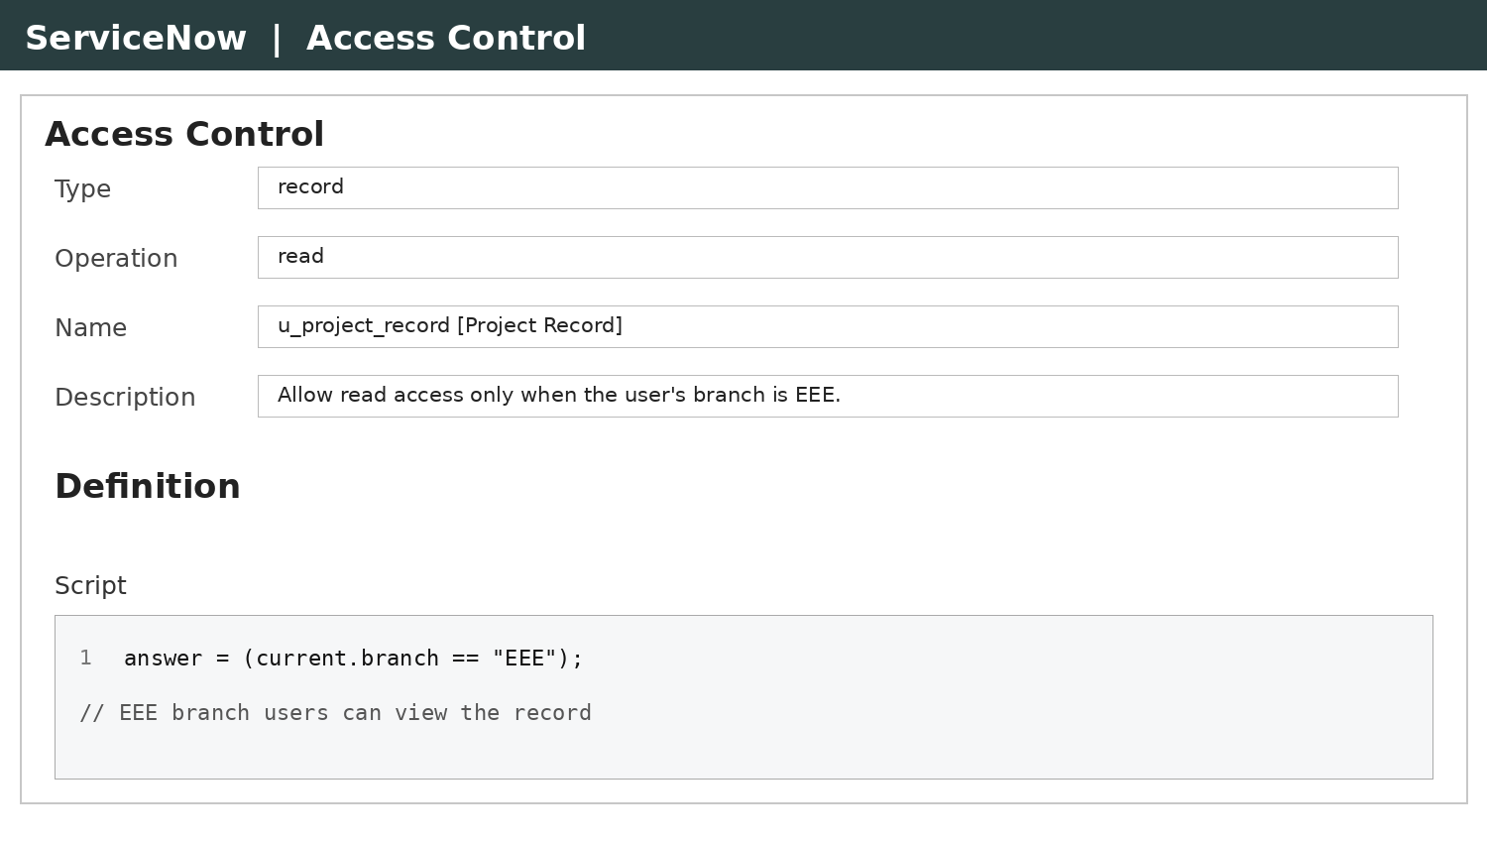  ACL configuration
2. | Accuracy | Test Result (Authorized – EEE branch user): Record visible – Pass  Test Result (Unauthorized – other branch user): Access denied – Pass | 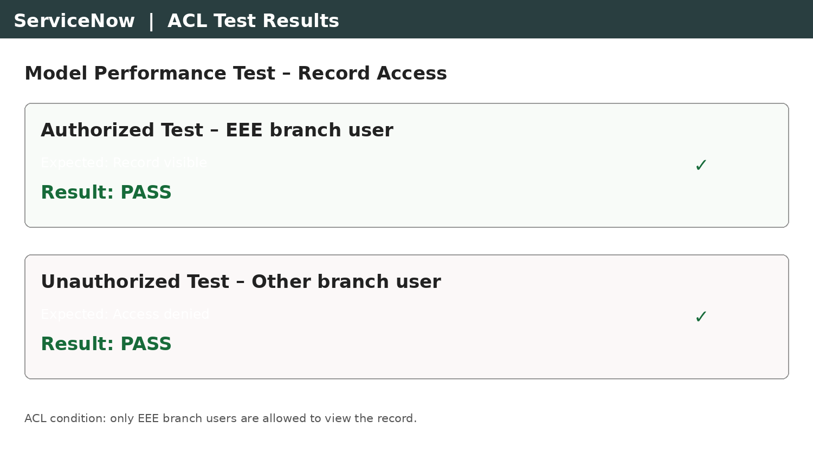  Test results
3. | Confidence Score (Only Yolo Projects) | Not applicable – this project does not use a YOLO object detection model. | –

